Game Design Document

Fill up the Following document

1. Write the title of your project.

Virtual Zoo

1. What is the goal of the game?

To aware the people, how to behave with animals

1. Write a brief story of your game?

People can go in a zoo and buy a ticket and moving in the zoo, feed animals and roam in the zoo, also the people can play animal related games..

1. Which are the playing characters of this game?

* Playing characters are the ones which respond to the user based on the input from the user
* Cars, monkeys, dinos, wizards etc, are the playing characters in the game.

|  |  |  |
| --- | --- | --- |
| Number | Character Name | What can this character do? |
| 1 | man | Moves in the zoo |
| 2 | women | Moves in the zoo |
| 3 | child | Moves in the zoo |

5. Which are the Non Playing Characters of this game?

* Non Playing characters are the ones which don't have an action or a behavior when the user interacts with the game.
* Hurdles, stones, bananas, coins, etc are non playing characters in the game.

|  |  |  |
| --- | --- | --- |
| Number | Character Name | What can this character do? |
| 1 | animals | Sounding and moving in the zoo |
| 2 | food |  |

Draw your imagination of this game. What does this game look like?

* Draw the game either on your computer or on paper,
* Add images of scenes of the game to show each of the playing and non-playing characters at least once.

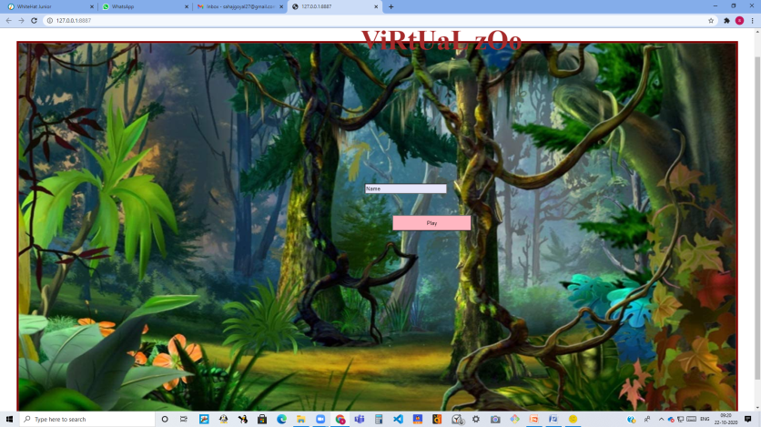

How do you plan to make your game engaging?

We make the game engaging buy making a lot of sounds, games(fruit catcher, fruit ninja, monkey game,etc.).and also with increasing and decreasing score.